**Selenium Test Case Execution**

1. **Starting Xampp Server to run sample PHP application**

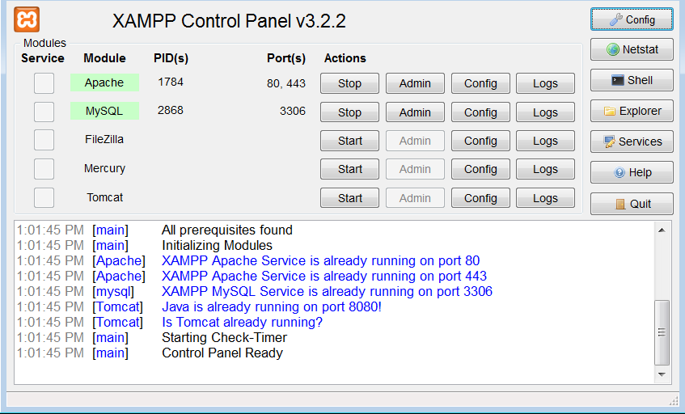

1. **Running Sample PHP application in Xampp Server**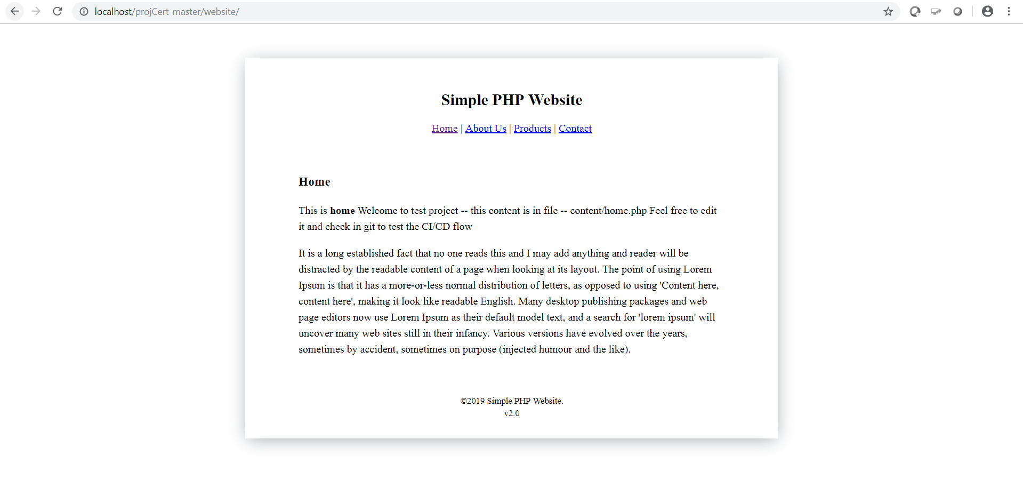
2. **Selenium Script to test PHP application**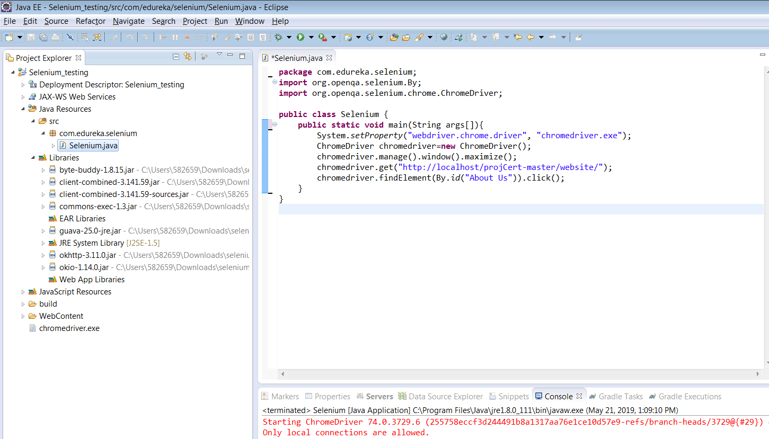
3. **Execution of PHP application after verifying “About Us” link**